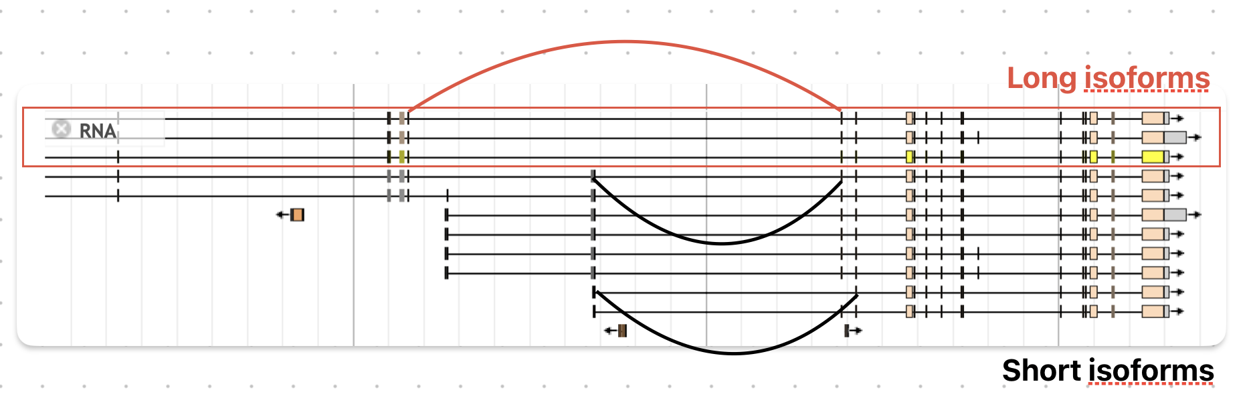

[Long isoform: E, O, P]’s unique junction: 12197255 > 12273935

Long isoform specific CDS: 12193604 – 12194223 > 12195769 – 12196623 > 12197186 – 12197255 (620bp, 855bp, 70bp)

[Short isoform with long isoform’s unique CDS as UTR: F, I]’s unique junction: 12197255 – 12204139, 12204409 – 12229666, 12197255 - 12229666

[Short isoform]’s unique junction: 12230370 - 12273935

